**MEMEBERS**

945 34 53 45

Alzira Valencia Valencia

**THE FUTURE IS IN YOUR HANDS**

Prof. Bernat Montagud nº3

Alzira C/ Prof. Bernat Montagud nº3

Alzira Valencia Valencia

**Andrés Rocher**

Designer

**Marc Naval**

Project Manager

**Lauren Ciucan**

Programmer

**Pablo Langa**

Writer

**DESCRIPTION**

Our application is aimed at people who can´t leave the house and carry out daily tasks, for example, going to the hospital, buying food, going to the pharmacy, shopping, running errands, etc…

The main objective of the application is to solve displacement, transport and mobility problems.

Another objective is to facilitate the meeting between several users to go to the same site and solve transport problems that may arise.

In addition, we would be creating a small business or job for people who want or need extra money.

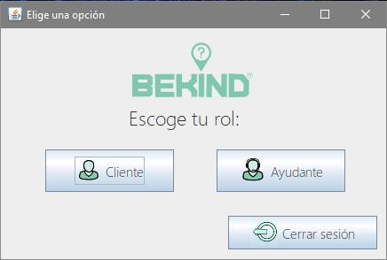

CONCLUSION

C1: it’s important to know how to develop the APP.

C2: is important to divide all tasks.

C3: keep all data safe.

C4: is the most important part.

C5: is necessary to sell it.

C6: is necessary because we made a video tutorial.

C7: is necessary if you don´t understand how the application works.

C8: we can’t make the presentation without the leaflet

C9: to know the labour risks.

RESULTS

Result 1: an overview of the application.

Result 2: to organize the tasks.

Result 3: to save the dates of APP.

Result 4: to develop and design the application.

Result 5: to sell the application.

Result 6: to present other topics.

Result 7: to explain how to running the APP.

Result 8: to do the projects presentation.

Result 9: to know the labour risks.

TASK

Task 1: Mock-Up

Task 2: Trello

Task 3: Data Base

Task 4: Programming

Task 5: English --> marketing

Task 6: Website

Task 7: Video Tutorial

Task 8: Leaflet

Task 9: FOL